This **main.py** file need to be in the same directory as all the attachment data files (h5, json, joblib) and image data files.

Requirements before running the code file:

1. Install pytesseract and save it in path, and call the directory out as seen in the code

2. Make sure to pip install pytesseract

3. The tensorflow version needs to be 2.5.0 to run the .py files (ANN model)

Introduction to image data

*File name - description

1. **Kaggle** - this file contains 230 car images (original)

2. **Kaggle_cropped** - this file contains 230 cropped license plate images (saved)

3. **Kaggle_subset** - this file contains 30 subset Kaggle car images (original)

4. **Kaggle_output** - this file contains 30 subset cropped licence plate images (saved)

5. **Malaysia** - this file contains 76 Malaysia car images (original)

6. **Malaysia_cropped** - this file contains 76 cropped licence plate images (saved)

7. **Malaysia_subset** - this file contains 30 subset Malaysia car images (original)

8. **Malaysia_output** - this file contains 30 subset cropped license plate images (saved)

Note:

Please change the folder name accordingly for each different testing.

In line 55 of the main.py code file, change the folder name when you need to test run the others.

Selection folders for line 55 is the original data image, user can change among:

1. Kaggle - 230 images
2. Kaggle_subset - 30 images
3. Malaysia - 76 images
4. Malaysia_subset - 30 images

In line 57 of the main.py code file, user can change the folder name accordingly for each license plate to be saved.

1. "Kaggle_cropped" will save the cropped-out images from "Kaggle"
2. "Kaggle_output" will save the cropped-out images from "Kaggle_subset"
3. "Malaysia_cropped" will save the cropped-out images from "Malaysia"
4. "Malaysia_output" will save the cropped-out images from "Malaysia_subset"

|  |  |
| --- | --- |
| folder (original) | dirName (saved) |
| Kaggle | Kaggle_cropped |
| Kaggle_subset | Kaggle_output |
| Malaysia | Malaysia_cropped |
| Malaysia_subset | Malaysia_output |

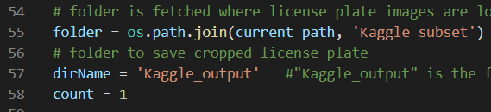

In line 157 and 158 of the main.py code file, user can change the folder name accordingly for each cropped license plate to be tested out.

|  |  |
| --- | --- |
| input_dir | numImages |
| Kaggle_cropped | 230 |
| Kaggle_output | 30 |
| Malaysia_cropped | 76 |
| Malaysia_output | 30 |

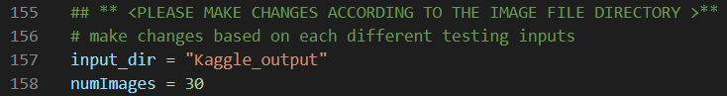

In line 179 and 180 of the main.py file, user need to comment out one of the binary when tested out with different datasets. The first binary is for Kaggle datasets, while the second binary is for the Malaysia dataset.

1. binary = cv2.threshold(img, 180, 255,cv2.THRESH_BINARY_INV + cv2.THRESH_OTSU)[1]
2. binary = cv2.threshold(img,180,255,cv2.THRESH_OTSU + cv2.THRESH_BINARY)[1]



Thank you! 😊